CIRCUIT 2 REPORT

- Description Of Modules
*** Light Sensor ***
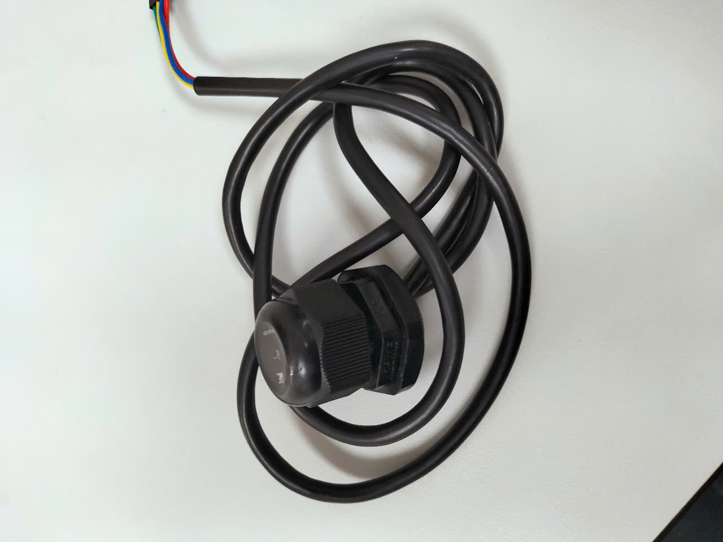
Light Sensor
Measuring light intensity in lux units.

*** Odor Sensor ***
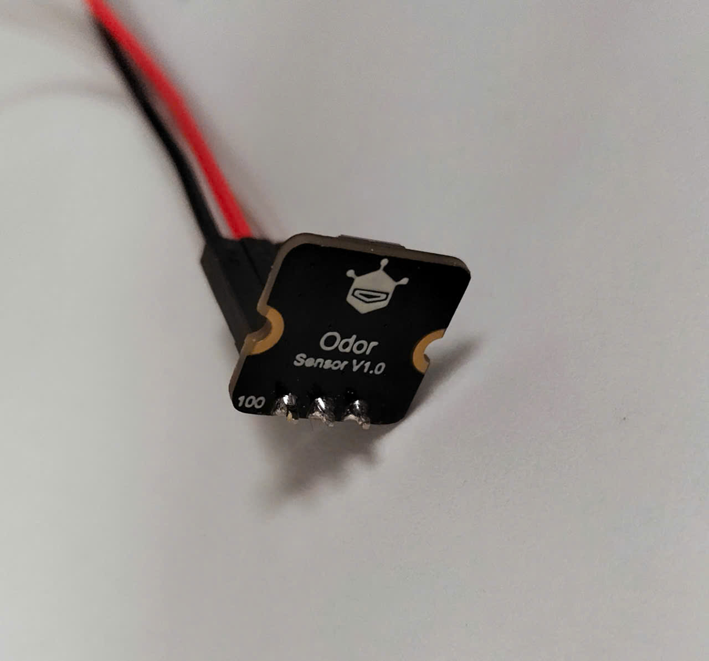
Odor Sensor
Measuring the concentration of odorous gases (H₂S, EtOH, acetone, etc.) in the air.

*** RTC ***
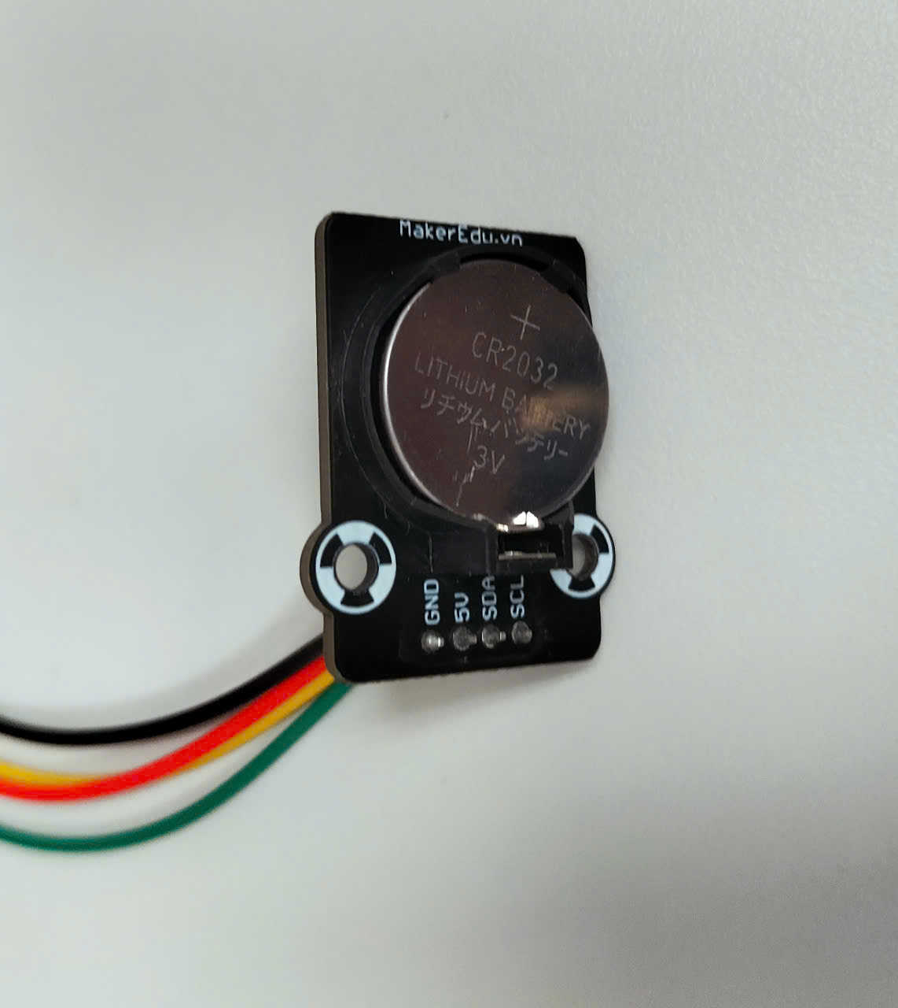
RTC
Getting the real time.

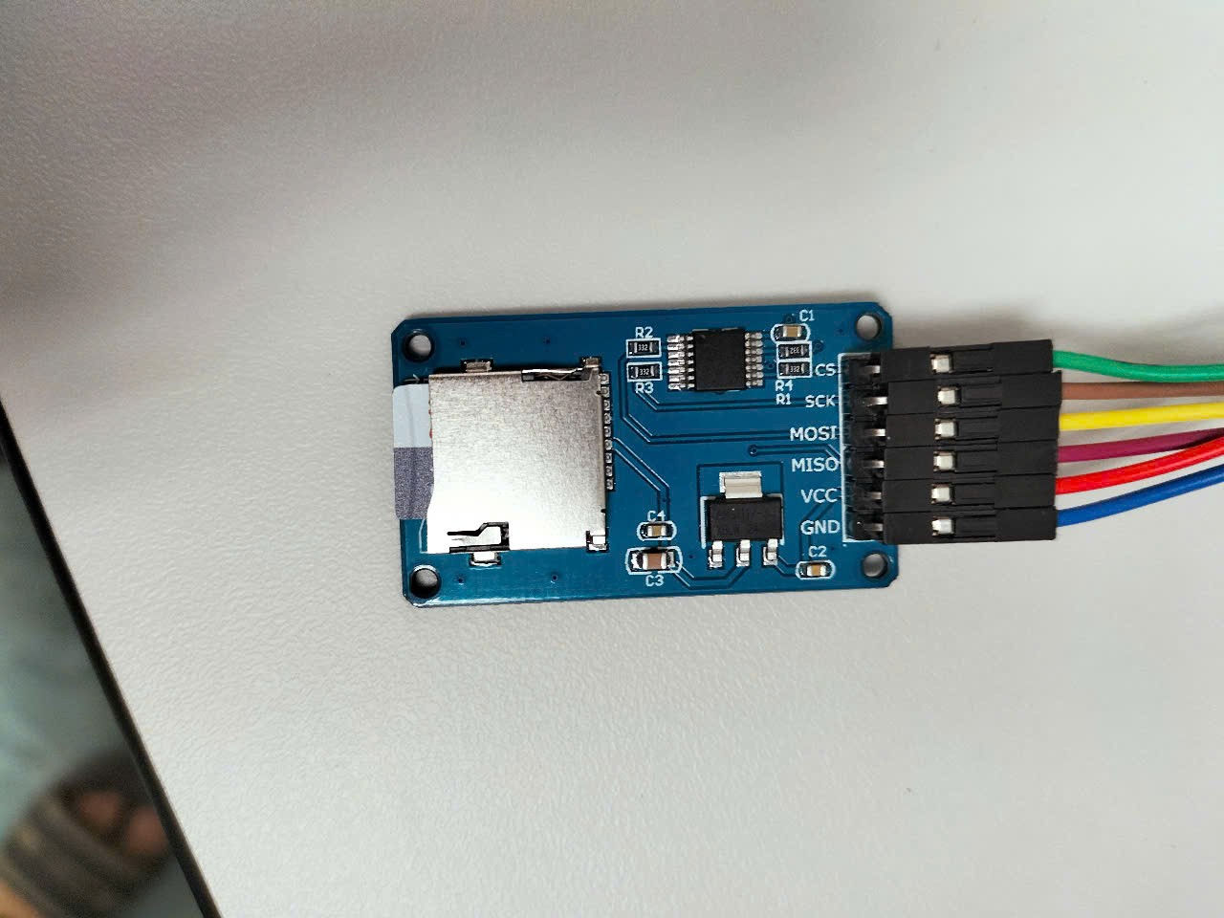
SD Card
*** SD Card ***
Write all collected data from above modules into micro card as file .csv.

- Pinout Diagram

- Code

